Positional Language |  | Maps and Plans
- Next to  - Behind  - Far from  - Under  - Left  - Right  - Forwards  - Backwards  - Turn  - North  - East  - South  - West  - First |  | Maps and plans are drawn using an aerial, or birds-eye view and usually include key features such as doors and furniture  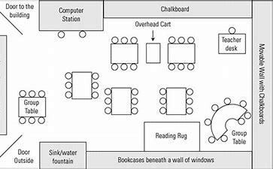  We are going to have a go at drawing our own plans, including using symbols  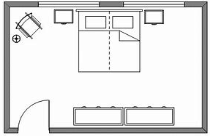
A Compass
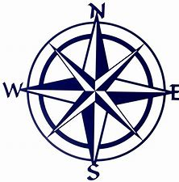
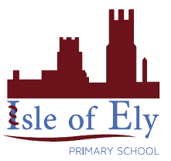
Knowledge Organiser
Autumn Term 2
Geography – Spatial Sense
Vocabulary
aerial view | The view from above – also known as birds-eye view
birds-eye view | The view from above – also known as aerial view
plan | A map or diagram
map | A representation of an area including key features
symbol | A mark or drawing the stands for something else
colour code | A system of marking things by colours as a means of identifying them
direction | The way someone needs to go or term for guiding someone to somewhere
perspective | A view that takes account of height, distance and relative positions
relative | In relation to something else
compass | An instrument that shows North, South, East and West

