Key Questions |  | Key Words for the Easter story
Who is Jesus?  Why is Jesus important to Christians?  Why are Christians christened?  What special times do Christians share?  When are Christian celebrations?  Why is Easter a Christian celebration?  What is Christmas and why do Christians celebrate it?  What is the nativity story? |  | Retell the Easter story using the key words.
The Nativity Story |  | Becoming a member of God’s family
https://www.youtube.com/#  watch?v=UP_2yp16A8k  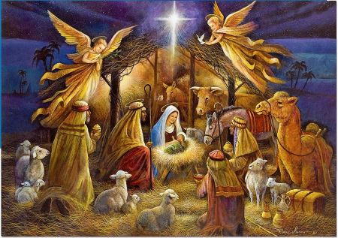 |  | A christening is a Christian blessing which usually involves baptism. And baptism refers to a ritual where a person (in this case a baby) is initiated into the Church congregation when water is sprinkled or poured over the head of a baby – or, in some cases, when the baby is immersed in water for a second or two. Christians believe this process means they become a member of God’s family.
Knowledge Organiser
Autumn Term 2
RE – Christianity: Jesus and Celebrations
Vocabulary
Jesus | Name of the man who Christians believe was the son of God.
Disciple | A personal follower of Christ during their life.
Worship | The feeling or expression of reverence and adoration for a deity.
Christened | Give a Christian name at baptism as a sign of admission to the church.
Christmas | The annual Christian festival celebrating Christ’s birth on the 25th December.
Advent | The first season of the Church year, leading up to Christmas.
Easter | The oldest festival of the Christian church celebrating the resurrection of Christ.
Harvest | The process or period of gathering crops.

